1

**4th May | WEEKLY | 2016**

**Real Estate Bill Becomes an Act Now**

***The act seeks to protect the rights of home buyers, mandates registration of projects, including those that have not got completion or occupancy certificates.***

**The Real Estate ( Regulation and Development) Bill, 2016, became an Act on May 1, kickstarting the process of making rules as well as putting in place institutional infrastructure to protect the interests of home buyers in India.**

**The Ministry of Housing & Poverty Alleviation notified 69 of the act’s 92 sections that come into force from May 1. Rules for implementing the provisions of the act have to be formulated by the central and state governments within six months – by October 31 – the maximum period stipulated in section 84 of the act.**

**The Housing Ministry will make the rules for Union Terrritories while the ministry of urban development will do so for Delhi. The Key to providing succor to home buyers will be the setting up of Real Estate Regulatories Authorities which will require all projects to be registered and the formation of Appellate Tribunals to adjudicate disputes.**



**For More Details, Please Contact Our Representative Today :-**

**Pratima Sarkar – 9873094775 Parikshit Jha -- 9711801195**

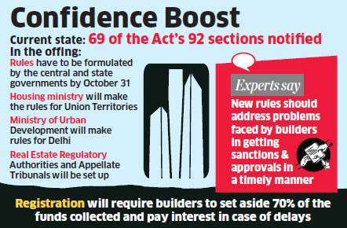

**Real Estate Appellate Tribunals**

**Once the regulatators are set up , they will get three months to formulate regulations concerning their functioning. Real Estate Appellate Tribunals need to be formed within a year – by April 30, 2017. These fast track tribunals will decide on disputes over orders of the regulators within 60 days.**

**A committee chaired by the secretary of the housing ministry has started work on formulation of model rules so that states and UTs can frame their rules quickly, besides ensuring uniformity across the country. The ministry will also come out with model regulations for the regulatory Authorities.**

**Real Estate Regulatory Act**

**The remaining sections of the act that have to be notifies relate to aspects such as the functions and duties of promoters, rights and duties of allotees, prior registration of real estate projects with the regulatory authorities, recovery of interest on penalties, enforcement of orders, offences, penalties and adjudication.**

**Considering that there are 12 months left for the regulatory authorities to be set up by the states, builders are expected to speed up work to avoid the stringnent provisions of the new real estate regulatory act.**

**Au Fait Fincare Pvt Ltd.**

**Office Address :-**

**301,Chanakya Complex,**

**B- 10,Subhash Chowk, Laxmi Nagar, Delhi – 110092**

**Website :** [**www.aufaitfincare.com**](http://www.aufaitfincare.com/)

**Section 20 of the Act**

**According to Section 20 of the act, state governments have to establish the regulatory authorities within one year of the law coming into force. The Authorities within one year of the law coming into force. These authorities will decide on the complaints of buyers and developers in 60 days.**

**The act seeks to protect the rights of home buyers , mandates registration of projects, including those that have not got completion or occupancy certificates.**

**Rgistrations will require builders to set aside 70% of the funds collected from buyers and pay interest in case of delays. Any Officer preferably the secretary of the department dealing with housing, can be appointed as the interim regulatory Authority.**

